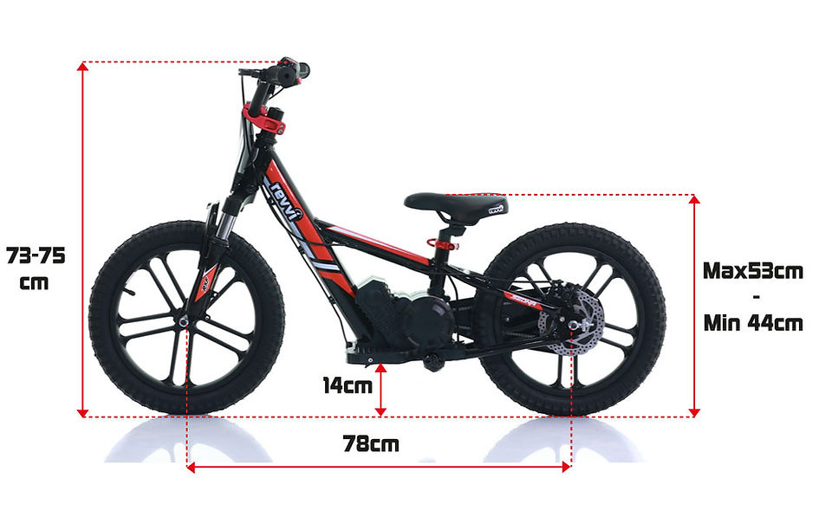
Revvi 16"Plus Kid's Electric Balance Bike

REVVI 16"PLUS KID'S ELECTRIC BALANCE BIKE
METAL FRAME + WHEELS, DISC BRAKE, FRONT SUSPENSION, BRUSHLESS MOTOR AND RUBBER TYRES
A super light electric-powered motor bike that has been specifically designed for kids, Weighing in at only 11kg's. The bike can be used as a conventional balance bike when learning to balance with its specially designed free wheel system. Then watch the rider improve and progress onto the slow speed setting (8mph) balancing on their own using the foot pegs. Perfecting their throttle control at the same time using the bikes twist throttle. Once they are confident using the slow speed setting they can then progress to the medium speed (10mph) and fast speed setting (12mph). Features hybrid rubber air filled tyres suitable for various ground types & a chain-driven motor that delivers reliable performance. The 16" Plus features the following upgrades over the standard 16" model - Front suspension, Metal wheels, rear disc brake, handlebar pad, full grip throttle, 3 speed settings, anodized handlebar, anodized seat clamp and a brushless 250w motor.
​

Age guideline:
​
- 5 Years + (Max rider weight 40kg)
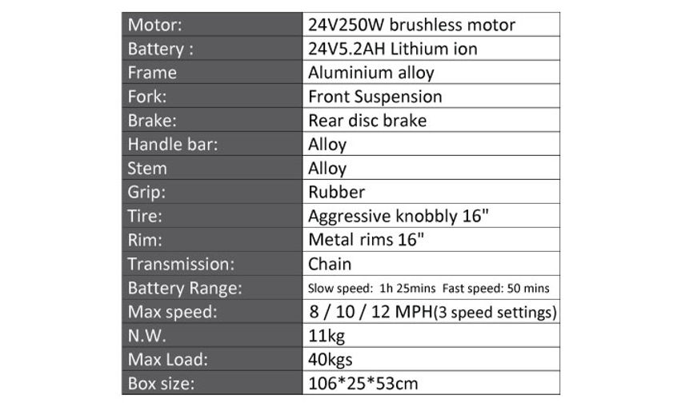
Key Features
​
-Removable battery fully enclosed within the bikes metal frame that can be changed in around 1 minute! The battery has a metal protection plate that is held on by 2 bolts to protect the battery from damage.
​
-The bike is supplied with 1 x battery, You can choose to purchase extra batteries.
​
-Each battery has a built in charging port, it can be charged in the bike or away from it.
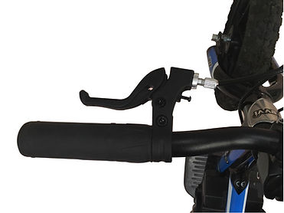
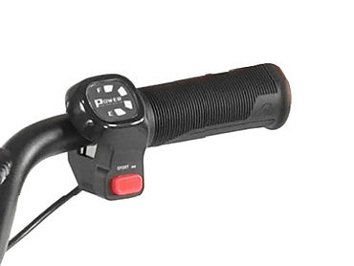
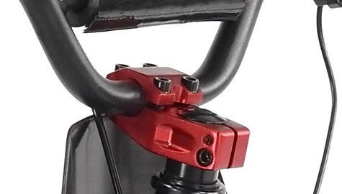
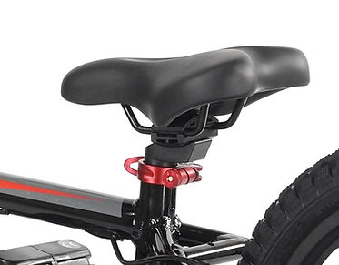
​
-Front Suspension forks

-Brushless 250w motor -This motor offers more acceleration over our other models and also increases battery life.
​
-Handlebar pad.

-Rubber air filled hybrid 16" 2.40tyres.

-Battery range: Slow speed - Approx 1h 25mins constant use
Medium speed - Approx 1h 05mins constant use
Fast speed - Approx 50mins constant use
Please note battery range will vary depending on the speed setting, rider weight and riding conditions.
​
-Three speed settings: Slow speed - Approx 8mph
Medium speed - Approx 10mph
Fast speed - Approx 12mph
Please note speeds stated may vary depending on riding conditions and rider weight.

-Charge time: 5.5 - 6 hours.

-Full grip twist and go throttle with battery level display.

-Chain driven.

-Specially designed brake lever for kids with rear disc brake.

-Light weight aluminium frame.

-Aluminium handlebars.

-Aluminium foot pegs with plastic cover for grip.

-Revvi graphics!

-External charge port for easy charging without battery removal.

-Lightweight metal 16" wheels.
​
-Anodized handlebar clamp.
​
-Anodized quick release seat clamp.
​
-Heavy duty adjustable seat.
​
-Specially designed rear wheel with free wheels system, this allows the bike to be used as a conventional balance bike with out the power.
​
-6 months parts warranty,
Please see terms and conditions for more info.
​
-Adjustable handlebar height, allows you to raise the handlebars by 20mm in 10mm increments as the rider grows.
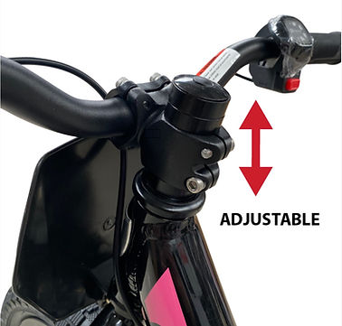
Number and Name Board Kit
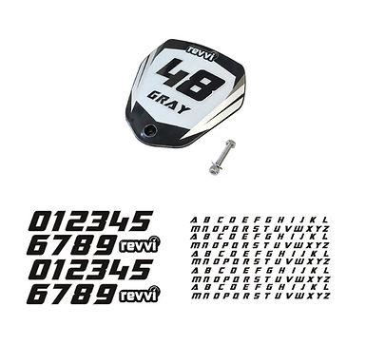
Included with every bike so you can customize your Revvi bike with race number and rider name.

The kit inlcudes:
1 x Black plastics race number board
1 x Graphic to cover the number board
1 x Sheet of letters to apply your name
1 x Sheet of numbers to apply your number
1 x Bolt for fitment
Colours
​
Available in the following colours:
Assembly
Bikes are delivered fully assembled minus the Front wheel, number board and handlebars. Please see owners manual for more information. All of the controls i.e throttle and brake lever are already fitted to the handlebars.
Each bike comes with a UK charger, owners manual and tool kit.

