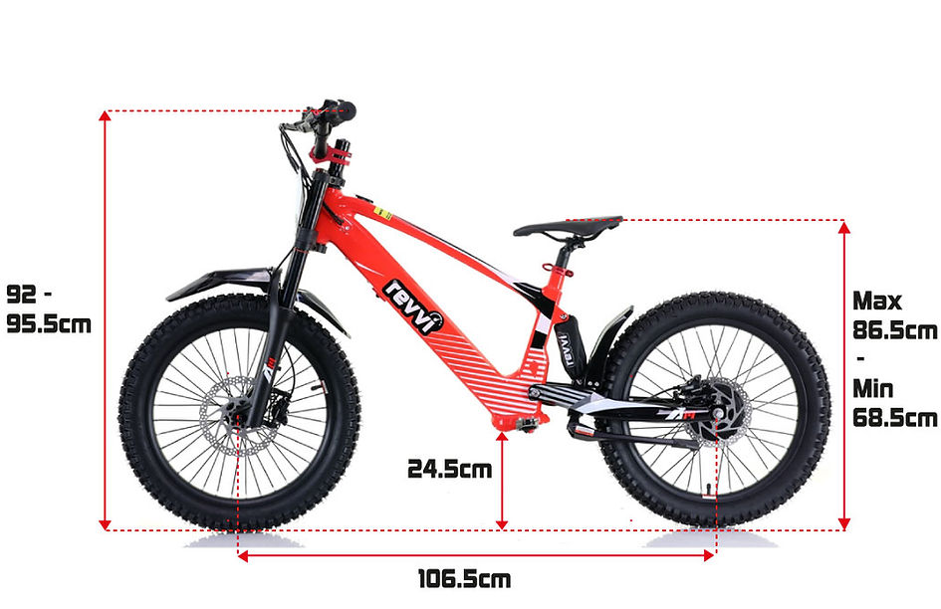

Revvi 20" Kid's Electric Motor Bike

REVVI 20" KID'S ELECTRIC BIKE
METAL FRAME + SPOKED WHEELS + HYDRAULIC FRONT AND REAR DISC BRAKES + FRONT AND REAR SUSPENSION + BRUSHLESS 36V 800W HUB MOTOR + RUBBER OFF ROAD TYRES + 3 SPEED SETTINGS
A super light electric-powered motor bike that has been specifically designed for 10 year old + riders, Weighing in at only 22.5kg's. The bike can be used on the slow speed setting (10mph) whilst the rider hone's there skills. Once they gain confidence they can progress onto the medium (16mph) and fast (22mph) speed settings. The bike features foldable MX style foot pegs and a full grip twist throttle. The bike also features Off road rubber air filled tyres suitable for various ground types & a hub motor that delivers reliable performance. The front and rear suspension offer's comfort while riding. Hydraulic front and rear disc brakes for great stopping performance.
​
​
​
Age guideline:
​
- Only suitable for riders of 10 years +. It is always at the discretion of parent or person supervising as to the age of the rider. CHILDREN MUST BE ACCOMPANIED BY AN ADULT. Start riding using the slow speed setting!
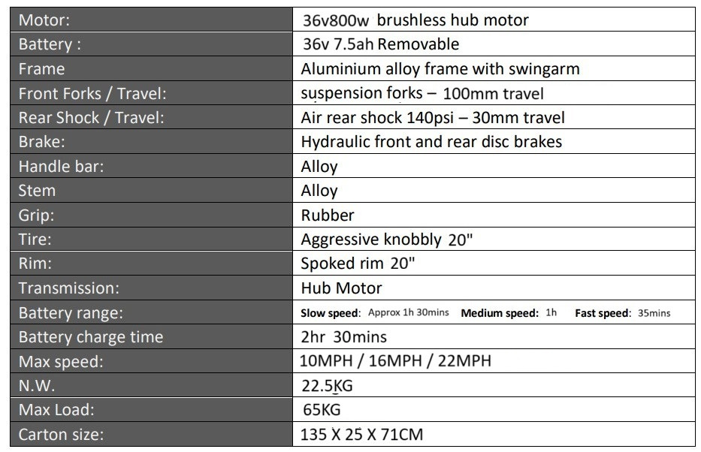
Key Features
​
-Removable battery fully enclosed within the bikes metal frame that can be changed in around 1 minute! The battery has a metal protection plate that is held on by 2 bolts to protect the battery from damage.
​
-The bike is supplied with 1 x battery, You can choose to purchase extra batteries.
​
-Each battery has a built in charging port, it can be charged in the bike or away from it.
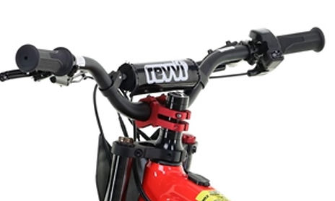
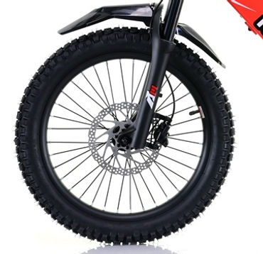
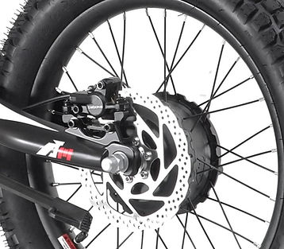
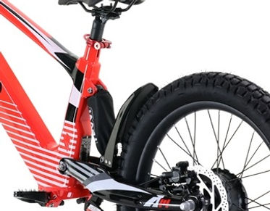
​
-Suspension forks – 100mm travel - Adjustable compression and pre-load.

-Air rear shock - Max 140psi – 30mm travel. You can release pressure from the rear shock to make it softer with slower rebound.

-Brushless 36V 800w Hub motor
​
-Handlebar pad.

-Large rubber air filled off road 20" 2.5 tyres..

-Battery range: Slow speed - Approx 1h 30mins constant use
Medium speed - Approx 1h constant use
Fast speed - Approx 35mins constant use
Please note battery range will vary depending on the speed setting, rider weight and riding conditions.
​
-Three speed settings: Slow speed - Approx 10mph
Medium speed - Approx 16mph
Fast speed - Approx 22mph
Please note speeds stated may vary depending on riding conditions and rider weight.

-Charge time: Only 2h 30mins.

-Full grip twist and go throttle with battery level display.
​

-Alloy brake levers - Adjustable reach.
​
​
-Hydraulic front and rear disc brakes.
​

-Light weight aluminium frame.
​

-Aluminium handlebars.
​

-Aluminium foldable spring loaded MX style foot pegs.
​

-Frame available in Red, Blue, Black, Green, Pink and Orange!
​
​
-Revvi graphics!
​
​
-MX style aluminium rear swing arm.
​

-External charge port for easy charging without battery removal.
​

-Lightweight metal spoked 20" wheels.
​
​
-Anodized handlebar clamp.
​
​
-Anodized quick release seat clamp.
​
​
-Heavy duty adjustable seat.
​
​
-6 months parts warranty,
Please see terms and conditions for more info.
​
​
-Adjustable handlebar height, allows you to raise the handlebars by 30mm in 10mm increments as the rider grows.
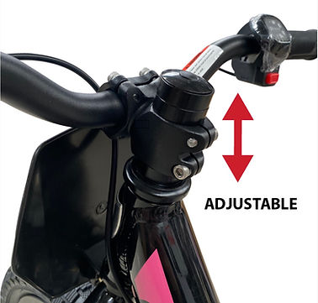
Number and Name Board Kit
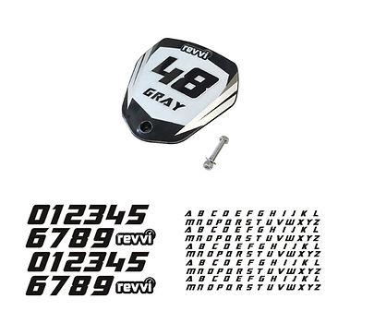
Included with every bike so you can customize your Revvi bike with race number and rider name.

The kit inlcudes:
1 x Black plastics race number board
1 x Graphic to cover the number board
1 x Sheet of letters to apply your name
1 x Sheet of numbers to apply your number
1 x Bolt for fitment

Assembly
Bikes are delivered fully assembled minus the Front wheel, number board and handlebars. Please see owners manual for more information. All of the controls i.e throttle and brake lever are already fitted to the handlebars.
Each bike comes with a UK charger, owners manual and tool kit.

